**­CSC 1101 – Problem Solving and Programming Laboratory – Winter 2019**

**Lab 05 – Trevor Trusty**

**25 points – Due January 29, end-of-class**

**a)** Save this document with your name and the lab assignment number somewhere in the file name.

**b)** Type/paste your answers into the document.

c) Submit this document and your .cpp file(s) to the Canvas item where you downloaded this document. Do not submit a zip file but individually attach your files.

You are hired to design a wall color cost calculator. Red costs $5 per square foot, Blue costs $1 per square foot, and Green costs $3 per square foot. Make a copy of the C++ template for your applicationand make the following edits:

1) Rename the copy you made to **yourName_InClass_Lab05.cpp** and save

it into your *CSC1101* folder.

2) Complete the header comment.

3) Modify the application header and close to contain the application name.

4) Declare three constants to hold each of the three color costs.

5) Declare two variables: **area** (type int) and **cost** (type double).

6) Using **cin >>**, prompt the user for an area.

7) Calculate the cost for each color based on the area of the wall.

8) Use formatted output to show the area and the three color costs formatted in two columns. The output should look like this:

**Area (sq ft): 100**

**Cost in red ($): 500.00**

**Cost in blue ($): 100.00**

**Cost in green ($): 300.00**

9) Run the program with at least three areas.

//==========================================================

//

// Title: Paint Helper

// Course: CSC 1101

// Lab Number: Lab05

// Author: Trevor Trusty

// Date: 1/29/2019

// Description:

// Helps users to calculate the cost of paint for walls with

// the area they specify, showing the cost of using red, green,

// or blue.

//

//==========================================================

#include <conio.h> // For function getch()

#include <cstdlib> // For several general-purpose functions

#include <fstream> // For file handling

#include <iomanip> // For formatted output

#include <iostream> // For cin, cout, and system

#include <string> // For string data type

using namespace std;

int main()

{

//Declare Variables

int area;

double cost;

int col1 = 20;

int col2 = 10;

//Declare Constants

const int RED = 5;

const int GREEN = 3;

const int BLUE = 1;

//Program Header

cout << "Welcome to Paint Helper!" << endl;

cout << "--------------------------" << endl << endl;

cout << "Paint Helper will help you calculate the cost to paint your wall." << endl;

//Promt user for wall area

cout << "Enter area of the wall you wish to paint: ";

cin >> area;

cout << endl << endl;

//CALCULATIONS

double redCost = RED * area;

double greenCost = GREEN * area;

double blueCost = BLUE * area;

//Show user their color prices

cout << fixed << setprecision(2);

cout << "================================" << endl;

cout << setw(col1) << left << "Area (sq ft): ";

cout << setw(col2) << right << area << endl;

cout << setw(col1) << left << "Cost in red ($) : ";

cout << setw(col2) << right << redCost << endl;

cout << setw(col1) << left << "Cost in green ($) : ";

cout << setw(col2) << right << greenCost << endl;

cout << setw(col1) << left << "Cost in blue ($) : ";

cout << setw(col2) << right << blueCost << endl;

cout << "================================" << endl;

cout << "\nEnd of Paint Helper" << endl;

cout << "Press any key to exit ...";

_getch();

}

**If possible, format your code like this:**

**Font “Courier New”**

**Font size “9”**

**Bold**

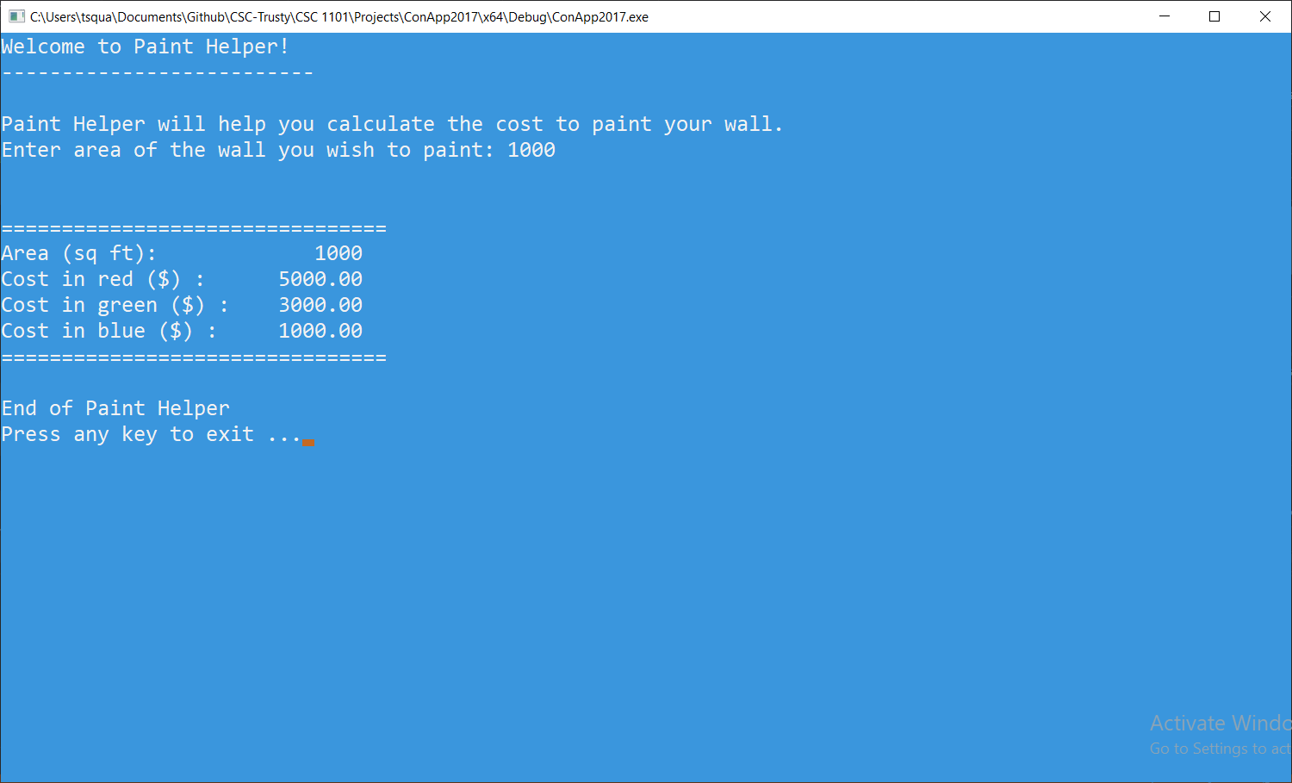

* **Copying-and-pasting Visual C++ code to a Word document**

1) From within the Visual C++ program, press **CTRL-A** and press **CTRL-C**.

2) From within the Word document, press **CTRL-V**.

** **Copying-and-pasting Visual C++ console application output to a Word document**

1) From the Visual C++ console, press **ALT-PrintScreen**.

2) From within the Word document, press **CTRL-V**.